INDUSTRIES WE SERVE

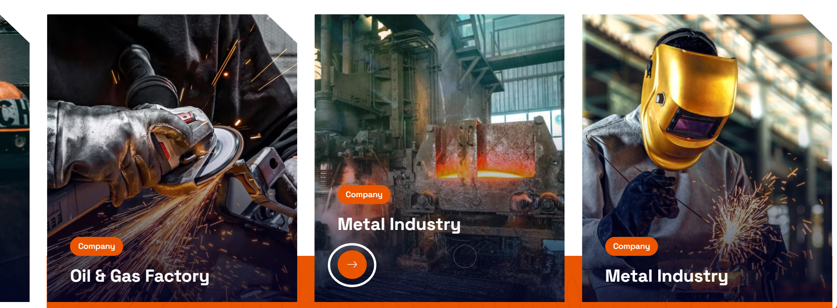

Remove Marked Circle and do not clickable effect anywhere on the image

- Sheathing Compound
Cable & Wire Manufacturing
Construction

- Transparent Compound
Medical & Healthcare
Packaging

- Solar Cable Compound
Renewable Energy
Power Projects

- FRLS and FR Compound
Power Distribution

- Insulation Compound
Telecom
Consumer Appliances

- Welding Compound
Fabrication & Heavy Engineering

